SAVEETHA SCHOOL OF ENGINEERING
SAVEETHA INSTITUTE OF MEDICAL AND TECHNICAL SCIENCES
INSTITUTE OF CSE
CSA15- CLOUD COMPUTING AND BIG DATA ANALYTICS
LIST OF EXPERIMENTS
11. Create a simple cloud software application for online super market using
any Cloud Service Provider to demonstrate SaaS with the template of
customer name, address, phone, email, items, quantity etc. with the item
classification form.

INPUT:
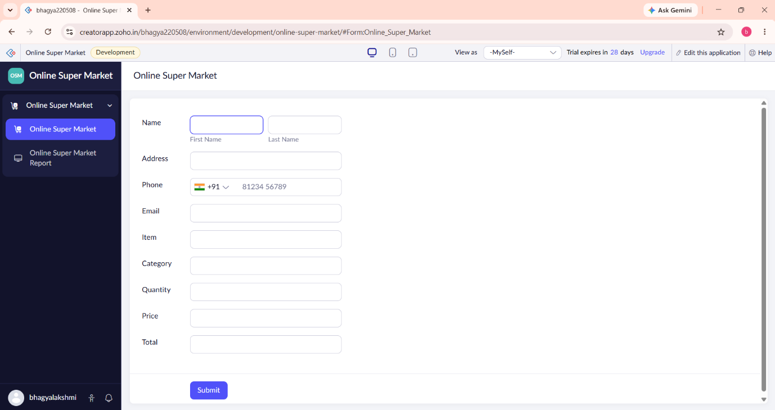

OVERVIEW:

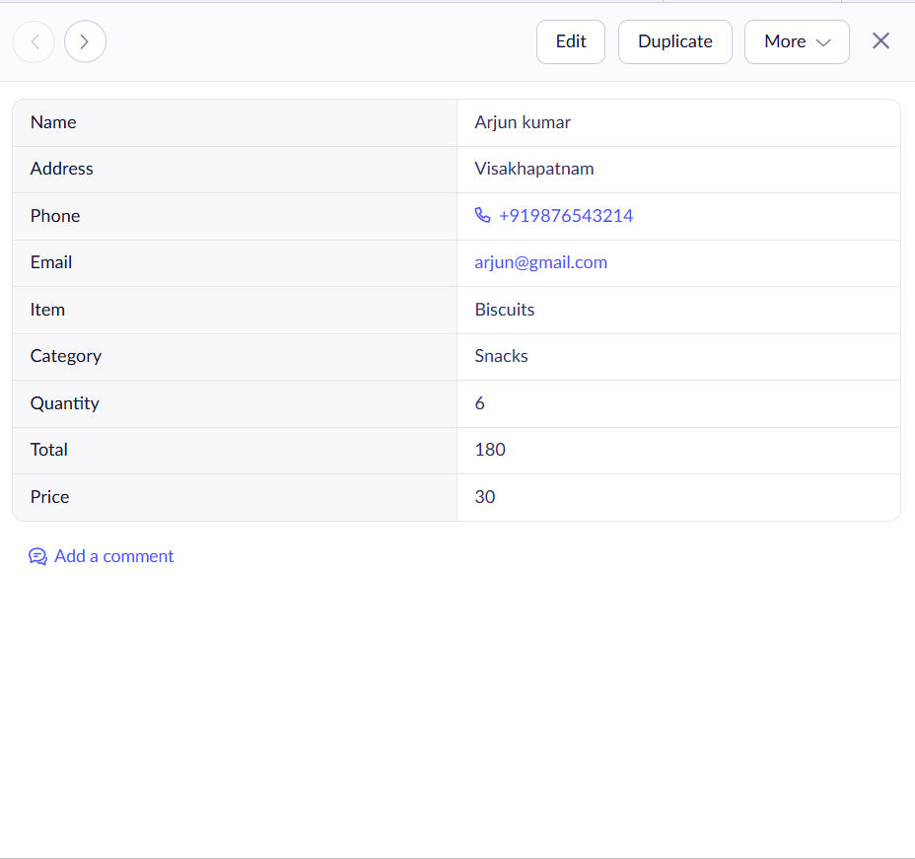

OUTPUT:
